Comparison of geochemical datasets for “Confirmation of Mg/Ca ratios as palaeothermometers in Atlantic limpet shells”

**Authors: Niklas Hausmann, Donna Surge, Ivan Briz-Godino**

# Overview

These supplementary files include the linescan information for Mg/Ca and 18O records of all analysed *Patella vulgata* and *Nacella* sp. shells, which were analysed to reassess the use of Magnesium to Calcium (Mg/Ca) ratios as palaeothermometers in Atlantic limpet shells.

# Patella vulgata

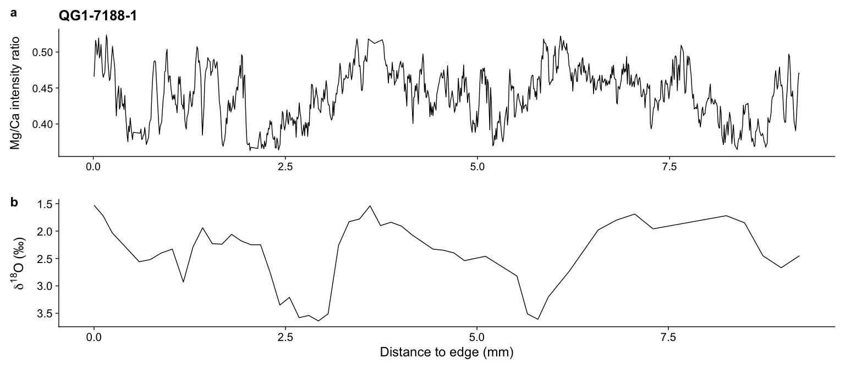

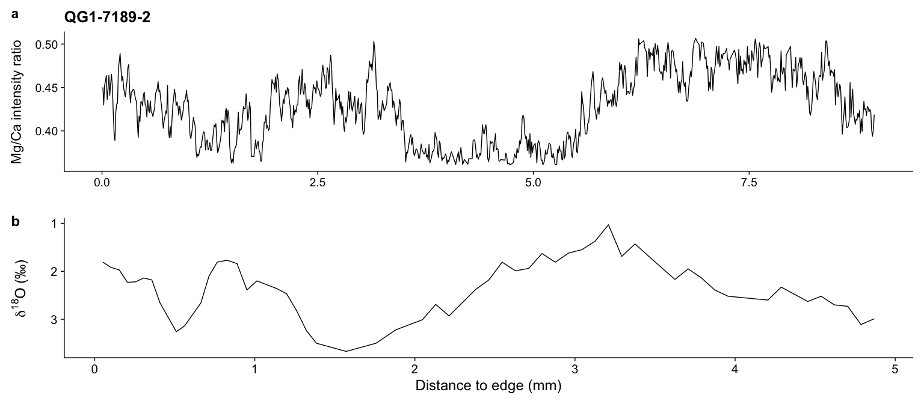

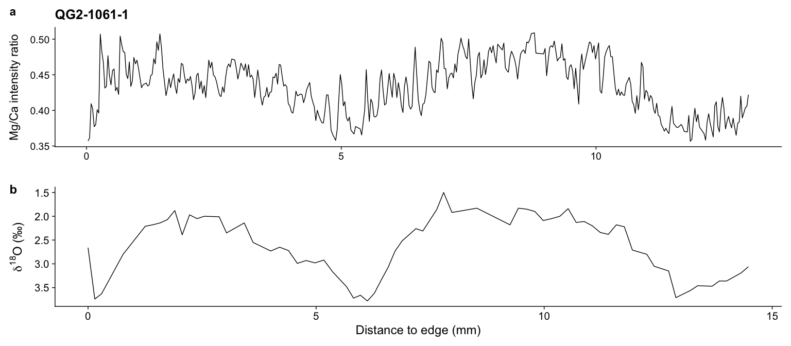

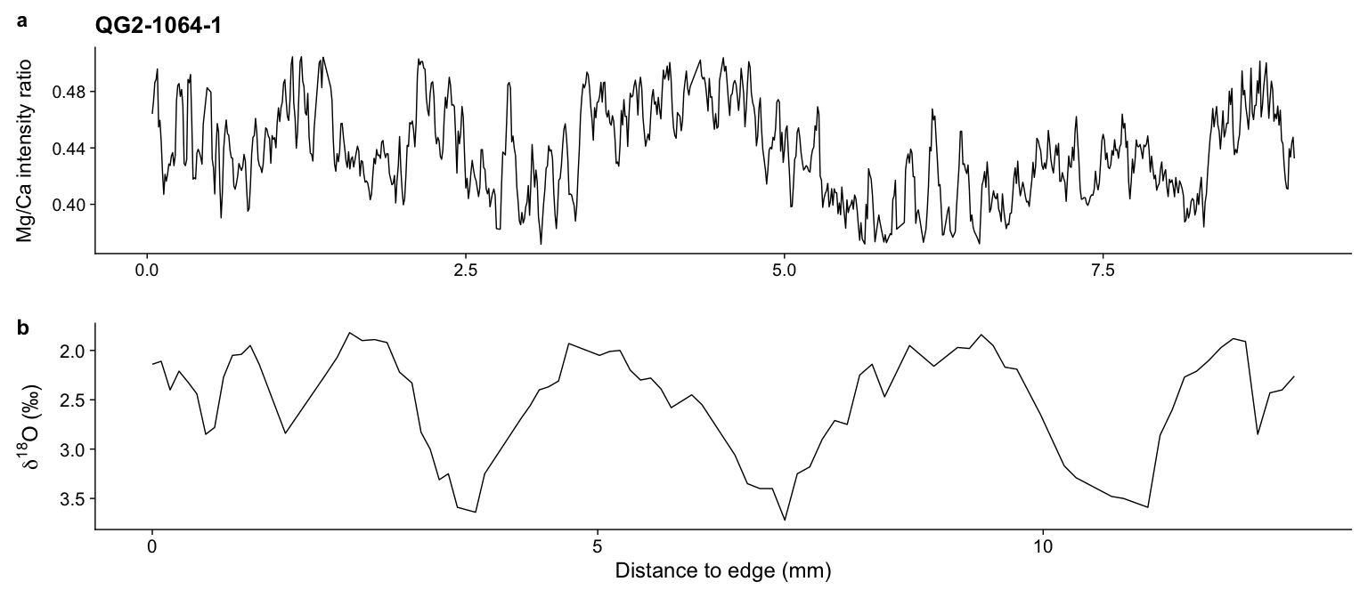

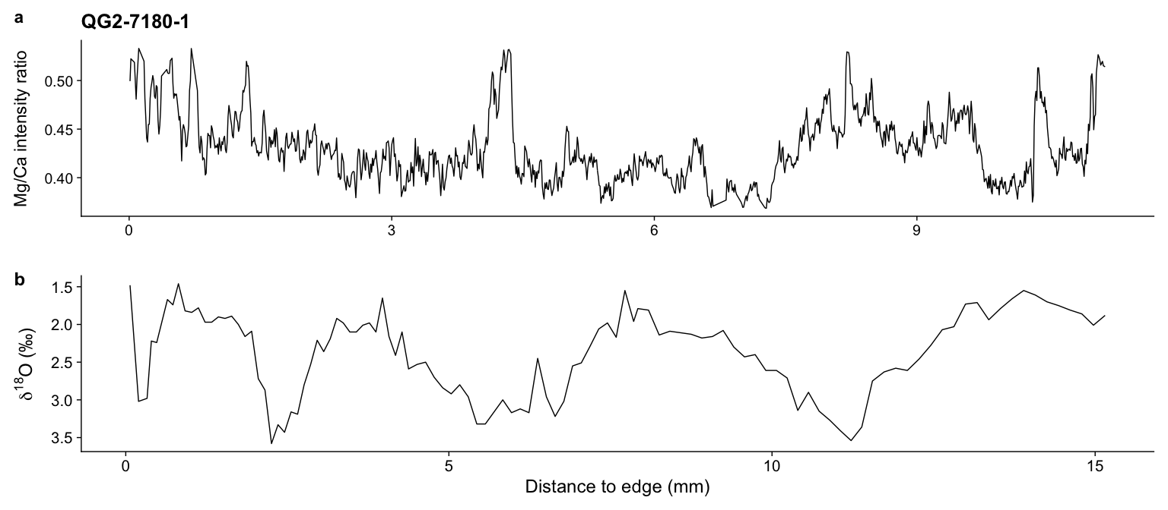

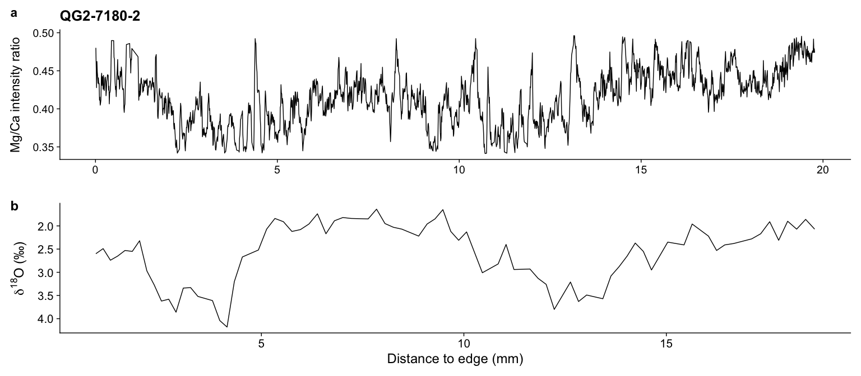

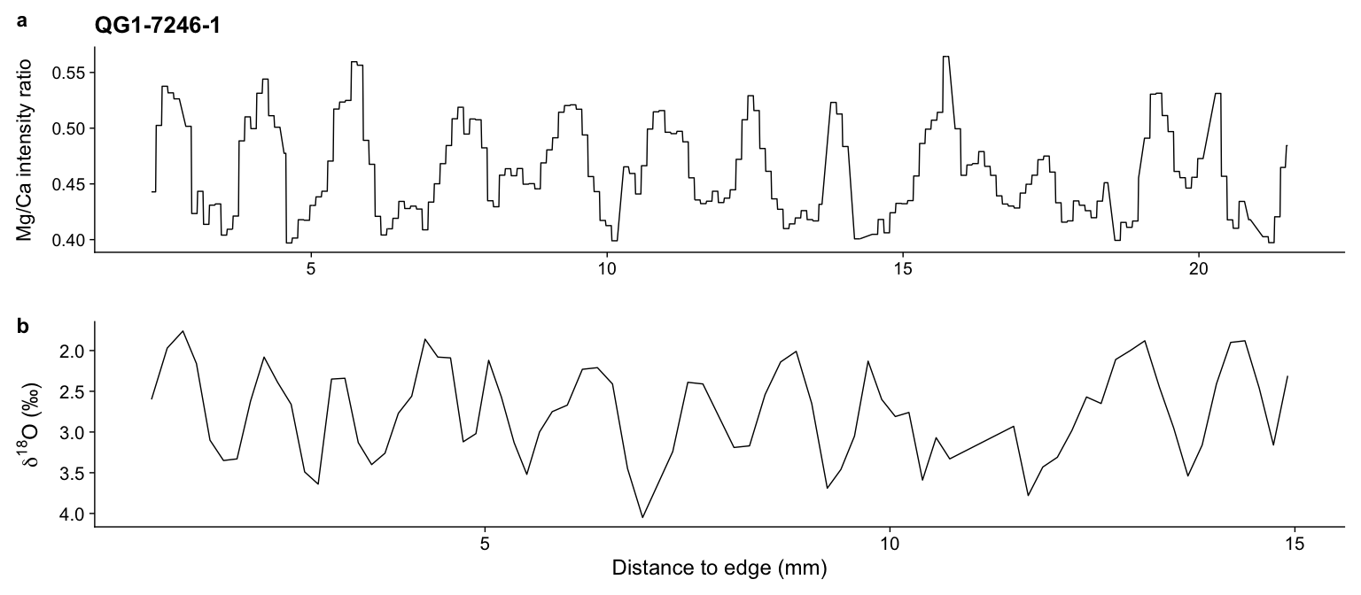

# Nacella deaureata

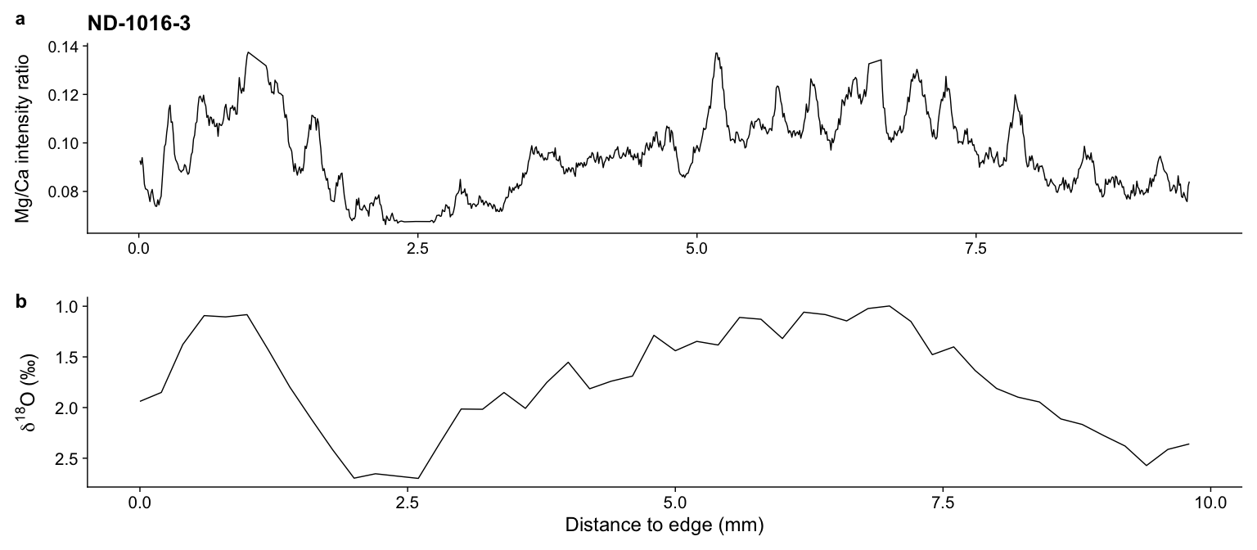

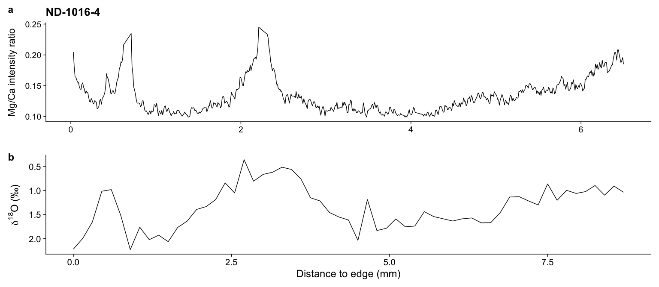

# Nacella magellanica

